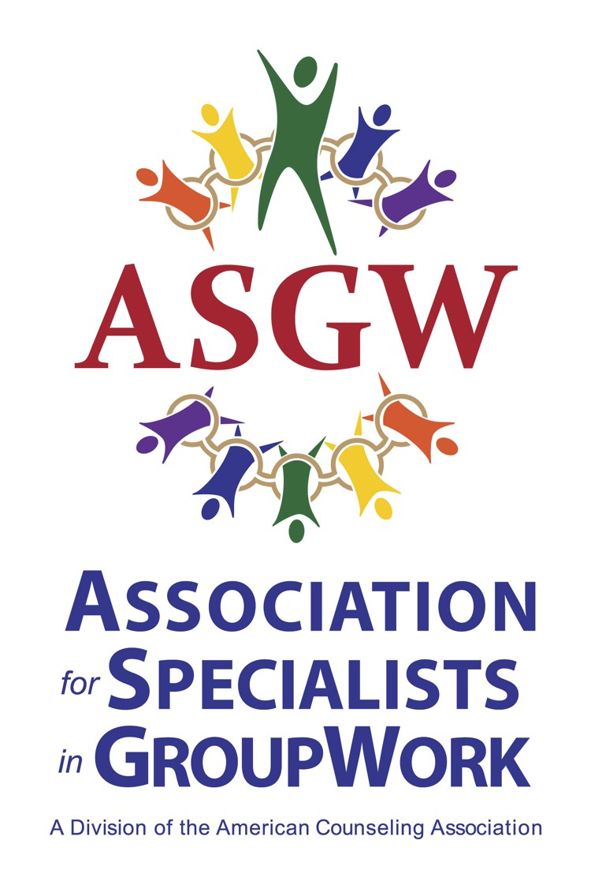

Call for 2023 Award Nominations - Deadline Extended
The Association for Specialists in Group Work (ASGW) is seeking nominations for awards! These awards are designed to recognize outstanding individuals for their significant group work contributions. The award recipients will be recognized at the awards ceremony at the ASGW Conference, February 9 -11, 2024, in Portland, Oregon.
Please consider nominating individuals the following awards:

• Group Work Practice Award: Recognition of an outstanding practitioner in group work in any area covered by the ASGW Professional Standards.
• Eminent Career Award: Recognition of career-long national and/or international contributions to group work by an ASGW member.
• Professional Advancement Award: Recognition of an individual’s efforts to advance group work through research, new technologies, legislation, public relations or practice
• M. Carolyn Thomas Outstanding Branch Award: Recognition of an ASGW state branch organization’s effort to promote group work in their state.
See below for descriptions and nomination criteria for these awards. Please send award nomination packets to Dr. Anastasia Henning at stacyhenning67@webster.edu. Please include the award name in the email subject line.
All nominations must be received by December 4, 2023. Recipients must be (or become) members of ASGW. Award winners will receive notification by December 11 to facilitate awardees’ travel arrangements to attend the ASGW Conference, February 9-11, 2024.

Award Descriptions & Nomination Criteria
Group Work Practice Award

The ASGW Awards Committee is seeking nominations for the Group Work Practice Award. The purpose of this award is to recognize an outstanding practitioner in group work. Recognition can be for any area of group work covered by the ASGW Professional Standards.

A nomination letter and two supporting letters should address the following:

1. Scope of practice of nominee to include:
a. Type of group work
b. Client population served
c. Practice setting
2. Innovations in group work practice by the nominee
3. How nominee has disseminated group work skills through workshops, conference presentations,
supervision, and/or training.
4. Evidence of nominee’s significant contribution to group work practice

Eminent Career Award
The ASGW Awards Committee is seeking nominations for the Eminent Career Award. Nomination letters should include:
• Nominee’s outstanding activities and contributions to the field of group work
This highest award is intended to recognize major contributions made to group work by an ASGW member. Credentials and letters of recommendation for the nominee need to convey the national and/or international influence the individual has had on group work (e.g. research, practice, education, promotion) throughout their career.
Professional Advancement Award

This award is made to recognize the outstanding activities of an individual who helped advance the field of group work through any one of the following:
• Research
• Development of a new technique or theory
• Public relations
• Legislative activities
• Group work practice

M. Carolyn Thomas Outstanding Branch Award
The ASGW Awards Committee is seeking nominations for an outstanding ASGW state branch. Self- nominations are welcome. In the nomination letter, please include:
• Important accomplishments made by the state branch in the last year
o Include workshops, publications, membership service, any special activities
• Supporting materials

