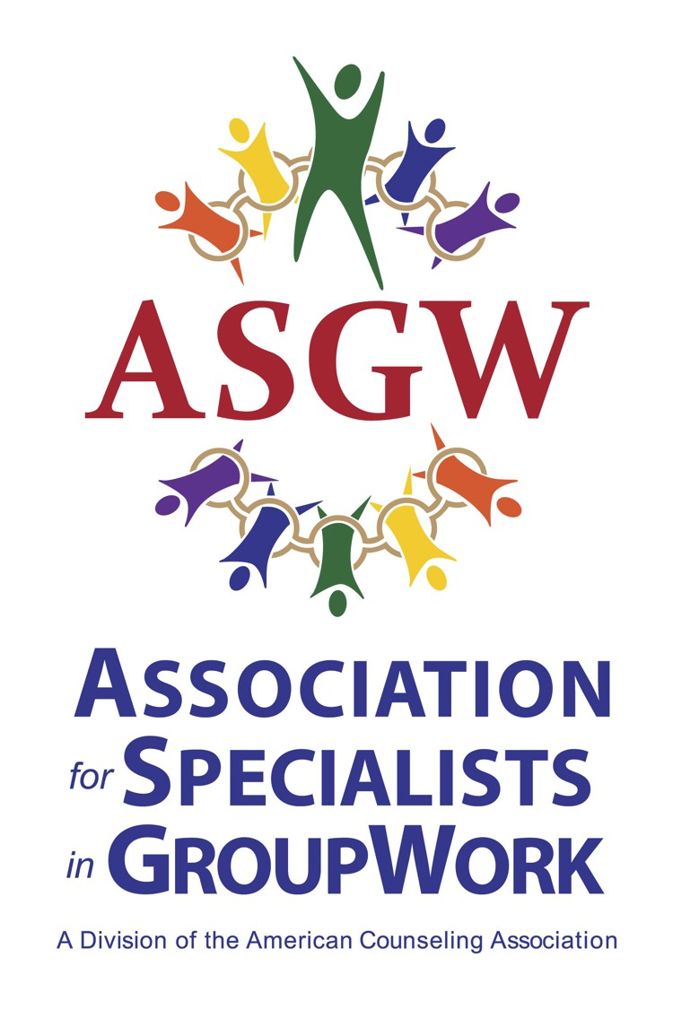

Call for 2024 ASGW Scholarship Nominations- Deadline Extended
The Association for Specialists in Group Work (ASGW) is seeking nominations for student scholarships! These scholarships are designed to support students in their pursuit of group work training, practice, and/or research. The recipients will be recognized at the awards ceremony at the 2024 ASGW Conference, February 9 & 10, in Portland, Oregon.
Applications are sought for the following scholarships:

- Peg Carroll Scholarship: A $2000 scholarship to support students’ continued group work training and development.
- Barbra Gazda Scholarships: Two $250 scholarships to support students’ attendance at the 2024 ASGW Conference.
- Rex Stockton Scholarship: One $1000 scholarship to support an international student’s attendance at the 2024 ASGW Conference.
See below for descriptions and nomination criteria for the scholarship. Please send award nomination packets to Dr. Anastasia Henning at stacyhenning67@webster.edu. Recommendations and letters of support must be sent from the referral source’s email account. Please include the award name in the email subject line.

All nominations must be received by December 4, 2023. Recipients must be (or become) members of ASGW. Award winners will receive notification by December 11 to facilitate awardees’ travel arrangements. Recipients of the Gazda and Stockton Scholarships are expected to attend the conference, and all award recipients are encouraged to attend the conference to receive their award during our ceremony.
Scholarship Description & Criteria

PEG CARROLL SCHOLARSHIP AWARD

The ASGW Awards Committee invites applicants for this $2,000 scholarship. The scholarship is awarded annually to honor Marguerite “Peg” Carroll, former ASGW President and pioneer in group work. The scholarship is intended to support the study of group work and further understanding of group dynamics. Any student interested in the field of group work is eligible for consideration by the Awards Committee. Applicants are requested to respond to the following questions:
1. There are many types of group experiences such as: therapeutic and/or counseling, decision-making, task-oriented, psychoanalysis, quality circles, classroom meetings, etc. What areas interest you the most and why?
2. Where would you obtain training in your area of interest? Be specific in respect to trainers, institutions, workshop sponsors, etc. In addition, describe your intended degree program, if it applies.
3. In what setting(s) and with what population do you hope to use your expertise?
4. How do you plan to assess if you and your groups are making progress? Have you had any experience with these evaluation tools? Explain in full detail.
5. List the types of groups in which you have participated. Describe their duration and both the positive and negative aspects of each experience. Please also describe your role (participant, leader, intern, etc.).
6. Describe your participation in professional organizations related to group work.
Letters of recommendation should be solicited from THREE professionals in the field who are familiar with the applicant’s work. These letters may be from supervisors, mentors, major professors, or other individuals who are knowledgeable about the applicant’s work with groups. Recommendation letters should address topics such as group counseling skills of the applicant, evidence of ethical behavior, and evidence of professional commitment and potential.

BARBARA GAZDA SCHOLARSHIP
This award consists of two (2) $250 scholarships to support students and/or new professionals in attending ASGW national conferences. This scholarship is co-sponsored by ASGW and the Gazda Family.
Applicants must submit a 300–500-word written statement that:
- Confirms ASGW membership.
- Identifies the university and degree program in which the applicant is currently enrolled or from which the applicant recently graduated (including date of graduation).
- Includes a statement of the applicant's interest and experience in group work, including ways in which the applicant is likely to benefit professionally from attending the conference.

THE REX STOCKTON SCHOLARSHIP
This scholarship is awarded to support an international student to attend the ASGW Conference. The recipient will receive $1,000 to support the cost of attending the ASGW conference; the funds can be used for expenses related to conference travel and room and board. The winner will also receive complimentary conference registration.
The scholarship honors the work and achievements of Rex Stockton, an ASGW Fellow and pioneer in the field of group work. Rex has taught and mentored many international students throughout his career. He has also worked extensively to promote group work in Africa, with a particular interest in HIV/AIDS counseling in Botswana.
The scholarship will be awarded to a student who:
- IS not a U.S. citizen -AND-
- Is currently attending graduate school in a group-work related profession anywhere in the world -AND-
- Demonstrates an interest in the application of group work in an international setting.
In keeping with principles of social justice, this award is also open to individuals who have interest and experience in group work but limited access to group work training. Thus, individuals who are not graduate students but who are engaged in significant group work (task, psychoeducational, counseling or therapy groups) in a country in which graduate school options are limited or who are denied access to existing training opportunities in their countries due to political, religious, or social identity reasons are eligible for this award. Such applicants should describe their eligibility under these criteria in their written statement (see further instructions below).
Applicants must submit a written statement of no more than 750 words that:
- Identifies the university and degree program in which the applicant is currently enrolled. (If the applicant is engaged in significant group work in a country in which access to graduate school options is limited, the applicant should describe their educational background and current work situation, including their group work practice.)
- Includes a statement of the applicant’s interest and/or experience in group work, including the application of group work in international settings, as well as what the applicant hopes to gain from attending the conference.
Applicants should also provide one letter of recommendation that describes the applicant’s group work experience and potential. If the applicant is a graduate student, the letter should be from a professor, and should also confirm the applicant’s status as a current graduate student. If the applicant is from a country in which access to graduate school options is limited, the letter can be from a supervisor, mentor, or other individual who is knowledgeable about the applicant’s work with groups.

Revised 12.2022 AEC

