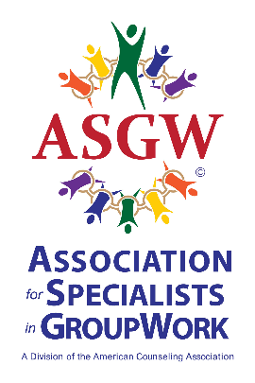
ASGW Call for Awards Nominations 2024-2025
In keeping with our mission to promote excellence in group work research, practice and leadership, ASGW is pleased to offer several award and scholarship opportunities to honor educators, practitioners, and students.

Nominations due December 1, 2024. Awardees will be notified by January 15, 2025. Awards will be presented in person at the ASGW Members’ Meeting held during the ACA Conference, March 27th-29th, 2025, in Orlando, FL- Day/time TBA. Award recipients must be (or agree to become) members of ASGW. For questions, scholarship instructions, and to submit nominations, contact Julia Champe (julia.champe@waldenu.edu).

EMINENT CAREER AWARD & PROFESSIONAL ADVACEMENT AWARD
Every year, ASGW Awards Committee seeks nominations for the Eminent Career Award and for the Professional Advancement Award. Nominations in either category should address the nominee’s outstanding activities and contributions to the field of group work. Additional letters speaking to the nomination would be welcome. Letters should identify which award is being sought.
Eminent Career Award: This highest award is intended to recognize major contributions made to the field of group work by an ASGW/ACA member. Credentials and letters of recommendation for the nominee should convey the national and/or international influence the individual has had on group work over a period of time.
Professional Advancement Award: This award is made to recognize the outstanding activities of an individual who has helped advance the field of group work through any one of the following: research, development of a new technique or theory, public relations, legislative activities, or group work practice.

PEG CARROLL SCHOLARSHIP

This annual $2,000 scholarship, honoring Marguerite “Peg” Carroll, a former ASGW President and pioneer in group work, supports students’ continued group training and development. For the application essay questions and full instructions, please contact Julia Champe (julia.champe@waldenu.edu)

GROUP WORK PRACTICE AWARD

This purpose of this award is to recognize an outstanding practitioner in group work. Recognition may be for any area of group work covered by the ASGW Professional Standards and nominees must be ASGW members (or be willing to join).
A nomination letter and two supporting letters should address the following points:
1. Scope of practice of nominee to include:
a. Type of group work
b. Client population served
c. Practice setting
2. Innovations in group work practice by the nominee.
3. How nominee has disseminated group work skills through workshops, conference presentations, supervision, and/or training.
4. Evidence of nominee’s significant contribution to group work practice.

